PHHH #1207.9

Date: Sun Jun 29
Hare: Dave "the body" - NYC hasher
Hounds: Itemized, Queef, Hey Yo! Paully, Hand Solo, and about 20 assorted wankers from the big apple NYC HHH
Virgin: who knows her name??
Weather: HHH as in hazy, hot, humid
Venue: Trenton RR cross Free bridge to PA, back on Calhoun St bridge

Hey Yo! Paully makes his way home to the waiting reception committee

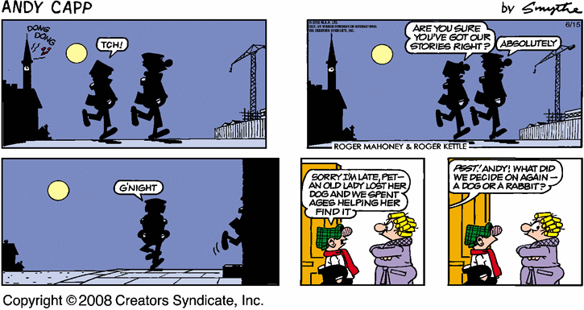

Despite having prescription dark polarized sunglasses, having departed after dark, having no helmet (still in my garage), no shirt (in velcro baggie under my seat) - I did make it home alright.
I got an earful from Juicy upon entering though. The dreaded "D" word was used loudly.
Thankfully, I had just enough alcohol in my stream to shrug it off (and to get home).
My legs were tired the next day - good pavement pounding sanwiched between to/fro Tour de Trenton-Lawrenevill e.
Please note though - I think I lost my bike lock - at the base of the first steel post outside the Wallenberg exit. maybe if any of you frequent that area - you can grab this masterlock for me. Other wise, I'll get rid of the key. Thanks.
Thanks you Solo and Queef for taking my wife's phone calls on your cell phones (or maybe Solo was rung twice with Queff being an intermediate mediator).
I couldn't leave, what with the beer being finsihed and the various vintages of wines being opened. What swill! And the conversation turned to bunyans (I even was forced to show my scar!).

Next Up:

#1208.9 5:00 PM Sun July 6 DP sets
It'll be in the Sourlands, north of Hopewell, but this time I won't be tempted to run downhill to Pashtun Territory. What we don't lose in elevation will be gained in Occifer-Todt- free mountain air. Exact start location will be posted soonish. The START TIME will be 5:30pm on Sunday, or when ever the 87 Prospector's arrive, which is likely 5:45pm.

#1209.9 3:00 PM 3:00 PM 3:00 PM 3:00 PM 3:00 PM 3:00 PM 3:00 PM 3:00 PM 3:00 PM Sun July 13 With a little help from 'bumps and pyro, Max the anxious aussie will set a special hash in Amber's honor.Hash cash (DONATIONS!! ) gratefully accepted... all proceeds will go to defray Oy! the vet bills.
Directions for #1209.9:

Directions for PHHH #1209.9 - Purple Paw Hash
Date: July 13, 2008 (make note to the visitor, 3 hours earlier than
GM standard time)
Time: 2:30 at 87 Prospect, 3:00 start
Hare: Worried Max Dog
Hash Cash (DONATIONS) gratefully accepted, all proceeds and matching hash cash will go to defray NS4H's vet bills. Beer, biscuits, and cheezy poofs will reward your generosity.
Start is parking lot under construction on Pleasant Valley Rd for Baldpate Mountain Park . The lot is marked with a "Green Acres" sign and not yet finished (may need to move cones to gain access). This is NOT the lot we have started from in the past!!
From Rt 95 take Rt 29 North ( River Rd ).
Right turn on Pleasant Valley Rd.
Parking lot is approximately 2 miles from the river on the right hand side.
From Princeton go to Pennington and go through Pennington to Rt 31,
Cross Rt 31 and proceed on Pennington Titusville Rd.
Go right onto Bear Tavern at Washington Crossing park.
Turn left onto Pleasant Valley rd.
Parking is approximately ½ mile on the left.
Again this is not the same parking lot that we started at about two
months ago and that DP ended at. If you go to that one, you are
lost.
#1210.9 6:00 PM Fri July 20 Friday Friday Friday Friday Friday Friday Friday Friday Friday Friday Friday Friday Friday Friday Friday Friday Friday Friday Friday Friday Friday Hand Solo sets
#1211.9 5:00 PM Sun July 27 WeePee sets
#1212.9 5:00 PM Sun Aug 3 ???? sets

