PHHH #966.9
Date: December 14, 2003
Place: Creative Marketing Alliance building,195 Clarksville Road, West Windsor.
Weather: Bloody Diabolical
Hare: Weapoea
Hounds: Hey Yo! Paully, Safe Sweats, Hand Solo, Sarah Moore (New Boot)
Time: 50 mins

At Christmas I no more desire a rose
Than wish a snow in May's new-fangled mirth;
But like of each thing that in season grows.
William Shakespeare (1564 - 1616), Love's Labour Lost

A rose we did not desire, but a hash we did. What is a hash? Apparently nobody knows ("HASH, x. There is no definition for this word -- nobody knows what hash is." Ambrose Bierce ,1842 - 1914, The Devil's Dictionary). So we misplaced our trust in the doughty hare, Wiiepji.

Weepee's life started out the usual way ("To my embarrassment I was born in bed with a lady." Wilson Mizner ,1876 - 1933). It was that first Christmas when his parents knew there was trouble:
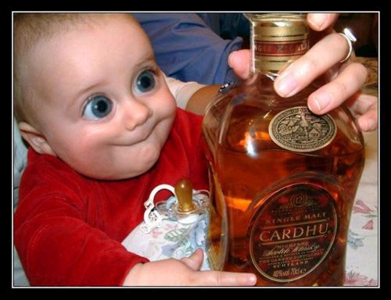
''Instead of solid accomplishments, this man pursues pleasures and self-gratification. He will never, never achieve anything so long as he is surrounded by dissipating temptations.'' - I Ching

At first, Wipaii led an indolent life ("Hard work never killed anybody, but why take a chance?" Edgar Bergen , 1903 - 1978). However, such a life with it's attendant ennui became too much even for Woieepi. (1. "Early to rise and early to bed makes a male healthy and wealthy and dead." James Thurber , 1894 - 1961, New Yorker, Feb. 18, 1939 "The Shrike and the Chipmunks"; 2. "A lifetime of happiness! No man alive could bear it: it would be hell on earth." George Bernard Shaw ,1856 - 1950, "Man and Superman" ,1903, act I)

Wiipii tried the intellectual route ("How to Raise your I.Q. by Eating Gifted Children" Lewis B. Frumkes, Book Title, 1983) and even attained the status of Ph.D. ("OK, so you've got a Ph.D. Now, don't touch anything." Anonymous) but soon settled back into a hum-drum existence ("Consistency requires you to be as ignorant today as you were a year ago." Bernard Berenson ,1865 - 1959). Maybe in the cosmic scheme of things this was the way it was meant to be ("I may not have gone where I intended to go, but I think I have ended up where I intended to be." Douglas Adams, 1952 - 2001).

It was with this baggage that our hare awoke this signal morning of Sunday December 14 in the year 2003 A.D. and experienced an epiphany ( 1. ''Today is your day! Your mountain is waiting. So ... get on your way.'' - Theodore Seuss Geisel; 2. ''The past is a ghost, the future a dream, and all we ever have is now.'' - Bill Cosby )

He suddenly knew what had to be done (''To know what is right and not to do it is the worst cowardice.'' – Confucius) and resolved to spare no effort to accomplish the goal ("We shall not fail or falter; we shall not weaken or tire...Give us the tools and we will finish the job. " Sir Winston Churchill ,1874 - 1965, BBC radio broadcast, Feb 9, 1941)

On this fine day, the hash wandered hither and thither ("Little by little, one travels far." J. R. R. Tolkien, 1892 - 1973) but finally, as all things must do, it came to an end ("Givers have to set limits because takers rarely do." Irma Kurtz, Cosmopolitan Magazine, September 2003)

In the final analysis, as H.P. Lovecraft himself might have said (but did not), "To be able to fill leisure intelligently is the last product of civilization, and at present very few people have reached this level. " Bertrand Russell ,1872 – 1970.

http://www.hplovecraft.com/
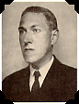

Enough said.

Next Hashes:

#967.9 Sun Dec 21 2pm Gird your loins, Hey Yo! Paully sets the Equinox hash
#968.9 Sun Dec 28 2pm Jimmy Ruckfutgers promises cold beer
#969.9 Sun Jan 4 2pm ??? kicks off 2004
#970.9 Sun Jan 11 2pm ??? sets
#971.9 Sun Jan 18 2pm ??? sets
#972.9 Sun Jan 25 2pm ??? sets

