 | PHHH hash #1182.9  Date: Sunday January 6, 2008  Hare: Hand Solo  Place: Great Wall Supermarket, Franklin Township  Counter-clockwise from the left:  - Scene of the Crime  - WeePee’s Remains  - Last Men Standing
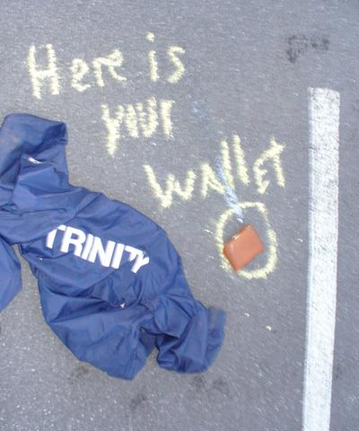 | 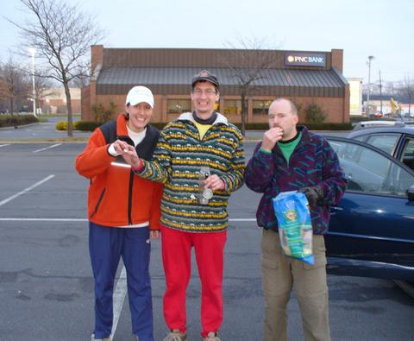
PHHH hash #1182.9
Date: Sunday January 6, 2008
Weather: Disturbingly good
Hare: Hand Solo
Place: Great Wall Supermarket, Franklin Township
Hares: Hey YO! Paully, Pyroman, Speedbumps, Little Blue Butt, Max the
Worried Dog, Wipi, Hare in my Zipper, Keyless Entry

No Picnic at Hashing Rock
(with apologies to Peter Weir)

Hashers Disappear on Beekman Road

(AP) Seven members of the Princeton Hash, including a dog, disappeared in the middle of Sunday afternoon after following a chalk and flour trail from the Great Wall Supermarket, police said last night. Phone calls from two spouses, one great with child, alerted authorities who otherwise had not heard about the unauthorized path through several townhome developments.

"We don't know where they went, and frankly we don't have a clue," said Detective Philip Dilip. "It would have been helpful if the hare had followed standard procedures and trailed the pack, but we've got a warrant to start digging up his backyard."

Hasher Found Behind 87 Prospect on Princeton Campus

(AP) One of the seven hashers reported missing earlier this afternoon was found dazed and dehydrated over eight miles from the reported start of the hash three hours after the start. Apparently named "Weepee," he was taken to the Medical Center of Princeton and given three liters of fluids and a pound of medicinal "Sport" beans. "Most of what he said
can't be repeated in reputable media," said Dr. No. "He responds to light stimuli and sounds ending with 'n.'" Asked whether the hasher had been exasperated, the doctor replied, "Regrettably, yes, and very badly so. Most trails have marks, and the Franklin Township police tell they found only one round white dot on top of a concrete culvert a quarter and several intersection from the two dots that Mr. Wipi mentioned."

Two other hashers were also found behind 87 Prospect and promptly arrested for trespassing. "Mr. Haio Paully and Ms. Kaylis Entree gave conflicting accounts about the trail they followed and their negligence in finding their fellow hare," Princeton officer John Webb explained. "They're in the pokey til they can explain what the hare did."

Next week: Wipi takes the Hash to Thompson Park in Jamesburg--Wacko, make your reservations now!

#####################################################################
And this from the hare:

Talk at the On In (reached after the regulation 60 mins) ran to the fate of the missing hound. Max was worried but then Max is always worried. Consencus had him back at the GW ordering a #8 youngasianchickwithlegs. The hare himself had an encounter of the sinistra kind when setting on semi-private land. The minivan backing out of the driveway stopped and the window rolled down. I fully expected the usual "get the F***** off my property" but instead she pushed back her gray hair and said "DWF ISO mature man for long walks on beach and possible LTR". I told her to google PHHH and ran off into the woods.
- hs
Sent via BlackBerry by AT&T

#####################################################################
And this from a nameless hasher (hint-HIMZ):

All be worried, be very worried, the almighty dictator of PHHH, fails to find marks, fellow hashers or Solo's car which was seen every ten minutes at the beginning of the hash. Weepe was able to find route 27, 87 Prospect (and all points inbetween), 2 paint balls (one of which decorated HYP's car) and a bag of abandoned Chocolate (which the well fed and watered hashers who laughed at his story ate most of)

Noteable quotes that wimpi failed to mention since he choose not to participate in the On-in

"If you could lick your balls you never would have gotten married"

and the other I fail to remember as the swill served wiped away all memories.

