PHHH #1173.851

Sun Nov 4, 2007

Hare: Hare in my zipper

Hounds: HYP, Le petit âne bleu, Délicate psyché, Solo Part, Vitesse Bosses,
Pyromanie Homme, Maximilian, Sécurité Seins, Le chaud stagiare, et TeBi

Weather: Appropriate

Venue: Quakerbridge mall and nearby ticklands and backroads

Halftruths: This was the closest HIMZ has come to setting a respectable hash
in years, and definitely better than the last one
(http://www.princetonol.com/groups/phhh/archive/1161.9.txt).
Carl and Lindsey (Sagan and Lohan?) greeted the other happy hounds at the start at the Firestone Store. They were evidently antsy, knowing that they had their work cut out for them, peeing on all the tires.Paully, Solo, and Wipi went shopping at the mall, but had put on too many pounds (or kilos in Solos case) watching football, gogo girls, and the history channel, respectively, on tv, and eating chips, crisps, and jelly beans, respectively, to fit into the slinky red dresses on display at Elizabeth Taylor. Ashamedly, they joined the rest of the pack into the woods and swamps. Much of the territory looked familiar
for anyone on Pyro, Bumps, et Olivier (RIP) sets
(http://www.princetonol.com/groups/phhh/archive/1079.9.txt - WB's 1st! - and
http://www.princetonol.com/groups/phhh/archive/1141.9.txt) or Exploding Feets'
(http://www.princetonol.com/groups/phhh/archive/1123.9.pdf).
We nearly lost Safety Titz and the Hot Intern to some roughian young punks at
a particularly innocuous looking housing development.
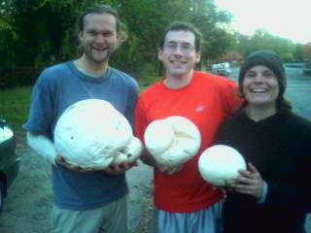

Many round, white objects were found and kicked, thrown, and carried to the onin, some of which will find tasty destinations in my kitchen this week.
Little Bleu Butt found a barbie jumbo jet which was hijacked, and will have exploded in the back of HIMZ's lesbian mobile by now.
RIP: Lindsey, Carl, and Charlie

Next up: Wipi sets November 11, noone has claimed November 18, and my claim is pending approval from the dealbreaker (i mean the windbreaker) for Nov 25.

