PHHH #1172.9

Sun Oct 28, 2007

Hare: Safe Sweats

Hounds: HIMZ, Three Balls, HYP, WeePee, Solo, Pyro, Speed Bumps, MaxDog

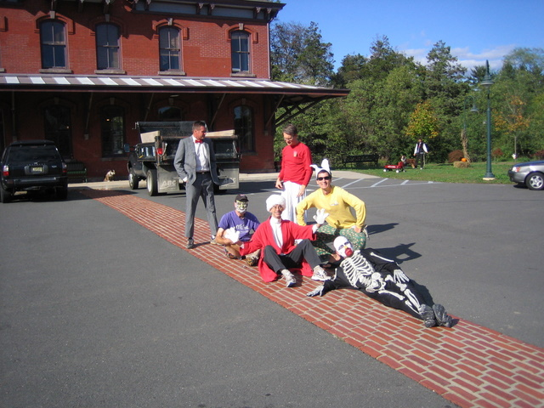 | 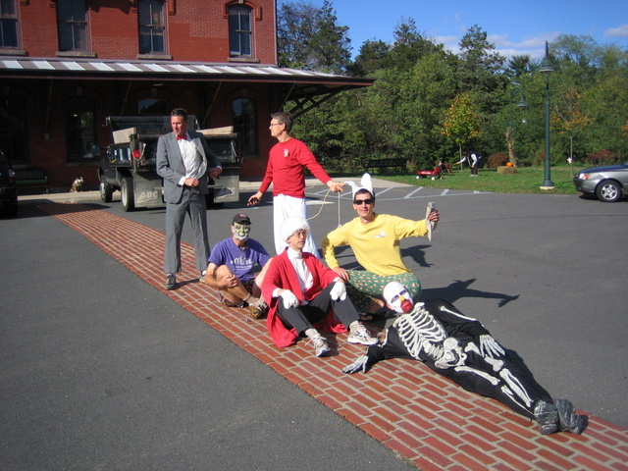
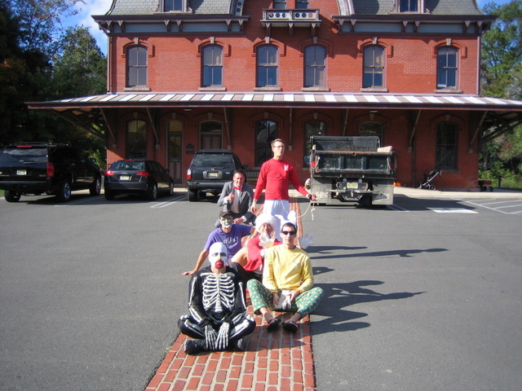 | 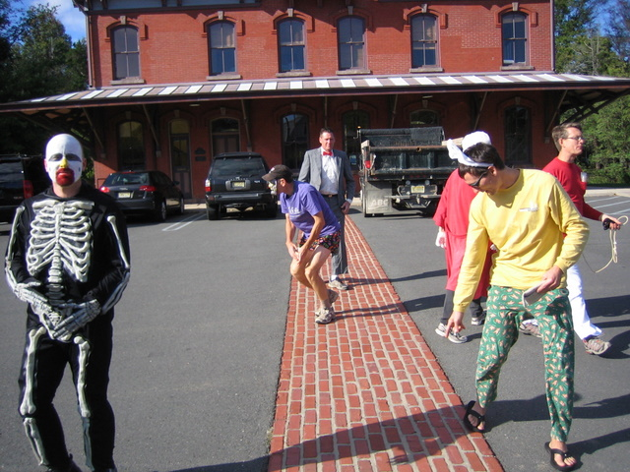

In case your wondering what everyone was dressed up as, we had: Peeweeinyourpants, plastic surgery gone wrong(but still as vast improvement) , safe sweats used plug of cotton, pussy gaglore, playgirl hare, bobble head bones and in background: social phobia pup and lesbian wannabe

