PHHH #1145.9

Date: Seis de Mayo 2007

Weather: Poifick

Venue: Plainsboro Ace Hardware to Bird Preserve

Hare: Exploding Feet

Hounds: Hey Yo! Paully, Pyro, Speed Bumps, Oliver the Wonder Dog, Warren, Delicate Psyche, Bjorn Dork, Hand Solo, HIMZ

Virgin: Lisa

Onin Food: Diplomatic

Seen On Trail: Safe Sweats à bicyclette

Time: 85 minutes

PhD Comics

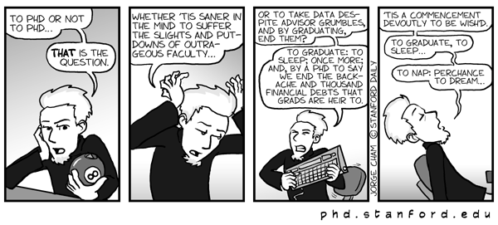

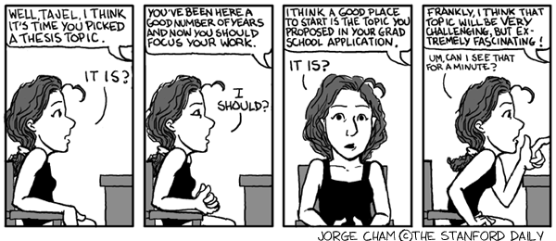

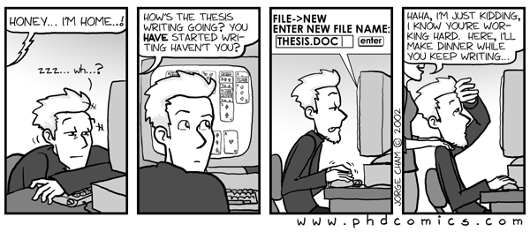
Next Hashes:

#1146.9 Sun, May 13, 2pm: Can we find a Mother to the Mother's Day Hash?
#1147.9 Sun, May 20, 2pm: ???? sets
#1148.9 Sun, May 27, 2pm: ???? sets
#1149.9 Sun June 3, 11am, Returning PHHH alums relive their inglorious past
SUNDAY 11AM SUNDAY 11AM SUNDAY 11AM SUNDAY 11AM SUNDAY 11AM SUNDAY 11AM SUNDAY 11AM SUNDAY 11AM SUNDAY 11AM SUNDAY 11AM SUNDAY 11AM SUNDAY 11AM SUNDAY 11AM SUNDAY 11AM SUNDAY 11AM SUNDAY 11AM SUNDAY 11AM SUNDAY 11AM SUNDAY 11AM SUNDAY 11AM SUNDAY 11AM
#1150.9 Wed June 6, 6pm: ??? sets
#1151.9 Wed June 13, 6pm: ??? sets
#1152.9 Wed June 20, 6pm: ??? sets
#1153.9 Wed June 27, 6pm: ??? sets

