PHHH #1134.9
Date: February 18, 2007
Place: Turkey Swamp
Weather: Pink and Poultry
Time: 2.5 hour
Hare: Owiepee, Full Moon Smiling
Hounds: Bjorn Dork, Delicate Psyche, Windbreaker, Quackenbush III,
Exploding Feet, HIMZ, Hey YO! Paully, Nuttin' Stuck, Pyroman,
Speedbumps, Oliver the Wonder Dog, Cliff Diver, Itemized Seduction,
Dancin' Fool, Safe Sweats, Three Balls, Chris Pilla
Visitors: More than we expected
Rambo crouched in his tent, adjusting the volume on his headset.
Dammit! Pressing a button on the nearby control panel, he sent a
shock pulsing through the airwaves. That'll teach that mutt to listen
to the Sirius Playboy channel when I'm supposed to be tracking him!
Back in Turkey Swamp, Oliver let out a yelp. Ouch... OK, OK sorry
Rambo, I'm back. The small camera hidden deep inside Wonderdog's fur
just a week before began beaming audio and video across the ocean.
Miles away, Rambo muttered to himself. I can't believe all of these
people! After all of the work I've done over the years to squelch
Princeton's reputation as a real hash, here we are, the annual hard
core, and I've had to hype it from afar while the PHHH threw
masquerade parties and decided to wear pink in honor of some candlelit
holiday. Hell, even the f*cking flour is pink!
Hi guys, more hashers! This is going to be great! Itemized... are
you going to drink all of that girly stuff? Yum! Frolicking through
dense woods and trail, we stopped for a quick game of Curling with
Hashers, and were soon at the first beer stop. Hey, you gonna eat
that cookie? I like hot chocolate!
Sons of Bitches! Rambo took a long draw from his Stegmeier. Ouipee
looks disturbingly upbeat... I knew it was a bad idea for him to set
with a cute chick.
More trail and woods... and the pack still more or less intact.
Across the frozen fields to one last beer check, mmm, green tubular
cookies this time... a little more running. Owie, I think I froze my
paws somewhere back there... thanks for the lift, Dork. Dammit,
Bumps, did you have to throw me into that stream? My toes really hurt
now... oh, good, ON-IN!
Rambo grumbled in the dark. Not one lost soul... even Cliff Diver and
IS made it in. The merriment continues, now inside a Mexican joint.
MEXICAN! Not a bitter melon in sight. Is that sangria on the table?
Blasphemy. Tossing another Steg bottle aside in disgust, Rambo
panned the bar one last time before cutting out. The waitress was
bringing a beer to a very short, sobbing man in the corner booth.
Worthless dwarf... Zaire will not be happy.

Pictures below …

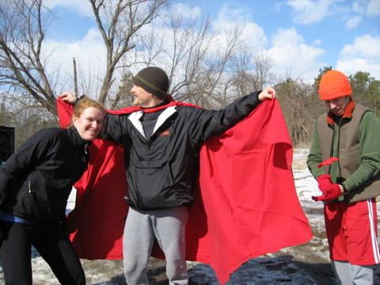 | 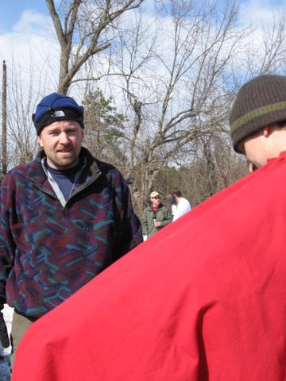
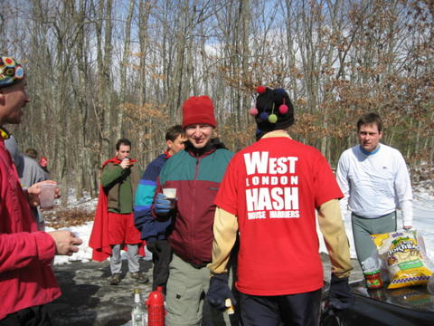 | 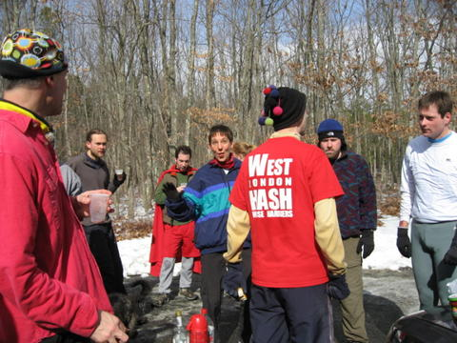
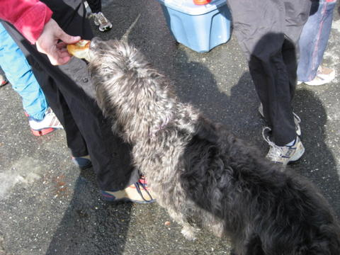 | 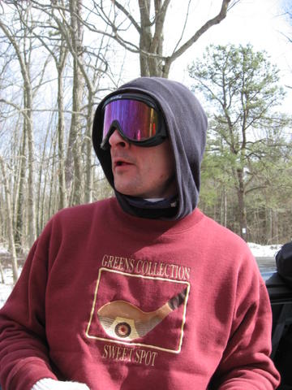
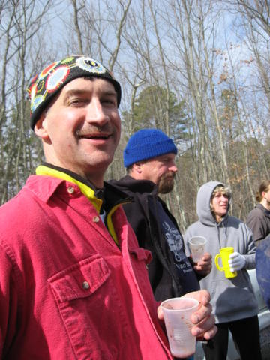 | 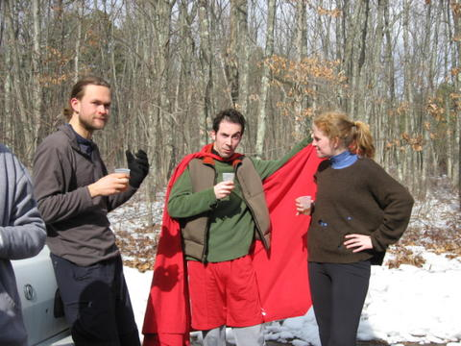
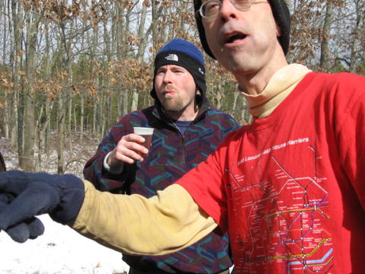 | 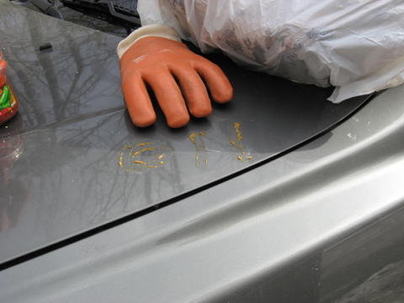
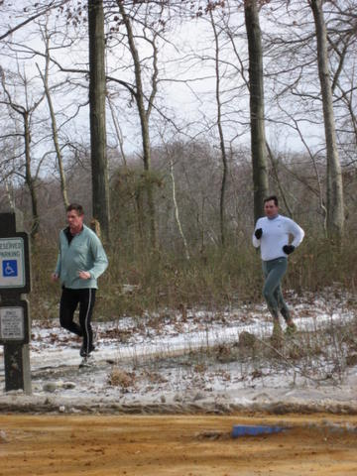 | 