PHHH #1081.9, Hard Corpse XIV

Date: Sunday, February 19, 2006

Weather: psychotic

Hare: Sjorn Dork and Delicate Psyche

Hounds: Oliver, Speed Bumps, Pyroman, Hand Solo, Dancing Fool, Charles Snellings,
Aaron (the vegan)Proujansky, Ksilent Knight, Hey YO! Paully

Time: 5 hours, not counting the police mandated shuttling of cars at the start Disturbed Provider
of the Beer Check Booze, and Grub: Dancing Fool

Wow, the pink marks lasted a whole week here in Locoland, even if they were on the backs of trees.  Good thing Dancin' Food had that day old hot dog for me; it carried | 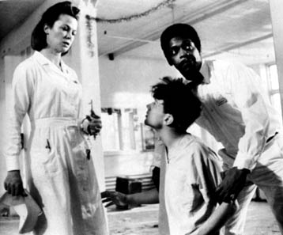 | me through the next 1 ½ hours  of romping over tangled trees and through thorns bigger than my toes.  Silly hashers, no need to rappel down a class 3 scramble!
Beer check #1, complete with birthday cake and pork rinds! Life is good! OK, back on trail...  look, snow! I love to roll in snow! Roll, roll, roll... hey, where'd everybody go? Guess I got  a little carried away; wait, there's Bumpy broken-toes limping up the road with her tail between  her legs. | 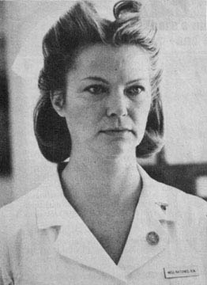 | Bumps, just click your heels together three times and... oops, wrong dog, wrong movie.  There's no place like Trenton.  Rambo, your fantasy journey garners no hashes. The numbers stand, as always, inaccurate and  official.
On Woof! Oliver the Blunder Dog
So all but Bumps, Dog, and Pyro made it to Beer stop #2, which was at the site of Bump's/Pyro's
beer check at the scenic overlook in High Bridge Park. More cake and disgusting snack - it was
very cold. Solo and Fool go home/work.

The four brave souls venture forth - Charles, Aaron, M Knight, and Hey Yo Paully. This was the
worst leg - all f'd up marks and we even ran into marks that set us straight 40 minutes prior!
Great! To top it off Aaron almost barfed up his green Spring Oreos. But alas, he kept his
composure and we eventually found marks, and marks, and more marks, and tracks eventually with
funny marks (it was obvious they were low on flour - ah the hare (we can run again)).

Great bar in High Bridge! Weepee will keel over when he sees the $405 bar tab (not including tip).
well let's see, creek crossings that didn't need to be, a rappel that didn't need to be and a
wandering through miles of forest looking for marks that sometimes don't exist, people dropping
out at the same rate as 16 year old drug dealers, half eaten sheet cake, pop-open bottles but no
opener, liposuction from a pig deep fried......we could call that a mess, debacle, fiasco or just
more simply hashing.

As I keep getting asked by my beeyotch when I walk in the door covered in mud, wet shoes, holes
torn in clothes, fingers numb, sheep hair caught in my zipper, slightly buzzed and talking of new
constellations, "You do this why?" And as I am left trying to find a way to explain to her 'why',
I realize that the question is just dumb so I promptly inform her that another beer better get
opened or else we will have trouble (not in the I am going to beat you sort of way, because that
happens whether there is trouble or not, but the I better not sober up too much or I might think
too much sort of way).

