PHHH #1012.9
Sunday, October 31, 2004
Location: East of Belle Meade
Weather: Blood Orange
Hare: Hand Solo aka Chicken Run
Hounds: Hey YO! Paully aka Mick Lite, Wacko aka the Executrix, Pyroman aka Duct Tapeman, Speedbumps aka Anthraxia, Bjorn Dork aka Turkish Delight, Salsa Bitch aka Bee-atch, Safe Sweats aka Shag Carpet, Count von Count Chocula, Ouipee aka Mrs. Richard Nixon, Homoerotic Mujaheddin Checking, Forrest aka George of the Jungle, Geezer aka Geezer.
Virgins: HMC's friend
Time: 1:30
Description, Polemics, and Lies
Trick or Treat at the Belle Meade Inn
"Where ARE they?" The Cuban Assassin, brightly attired in his Carmen Miranda outfit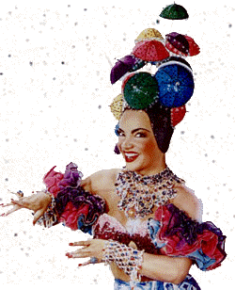, irritably hurled an empty Stegmaier's against the far wall and growled as the fragments of glass scattered across the battered rec room.
"Relax," said A. G. Zaire, decked out in a Betsy Johnson washed silk habutai evening dress 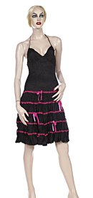 with matching handbag. "It's a Solo set. You know the drill as well as I do: obscure marks for half an hour, 30 minutes of running on roads, a talk with the local constable alerted to a bunch of crossdressing pedestrians, a beercheck with no beer, 30 minutes of running on the railroad. We'll be lucky if anyone makes it to the on-in, much less our apres. Jorge," he snapped the stumpy fragments of the fingers on his left hand, "another Stegmaier's, and make sure it's cold this time."
Our Wanda idly spun her lariat from her post on the bar, the spurs below her butter-soft llama-leather chaps stippling the woodwork in a dull tattoo. Just as the tension grew unbearable, Rojo, the Grand Dominatrix, appeared on the low stage stuffed in top hat, tails, and fishnet stockings and launched into a reasonable rendition of "Falling in Love Again."
But it was no use. Geezer, Wacko, Paully, Solo, and Weepee were comfortably settled in a glade by Solo's on-in and their own hazy past of yesterdays, regaling the wide-eyed students with tales of the Belle Meade Inn with no intention of taking them to a depraved den of iniquity only Ofay Hussein could love, least of all on All Hallow's Eve.

